Chemistry ATAR Year 12
Unit 3

Acid/BaseTitrations

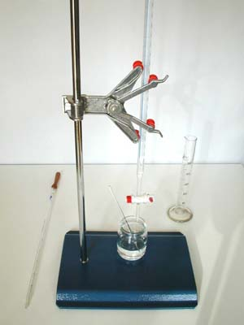

Volumetric analysis methods involving acid-base reactions rely on the identification of an equivalence point by measuring the associated change in pH, using appropriate acid-base indicators or pH meters, to reveal an observable end point.

Volumetric Analysis

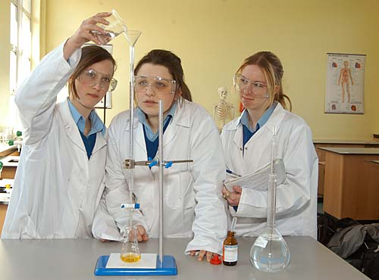
- Acid-base reactions can be used to determine information about unknown solutions.
- In volumetric analysis, the amount of a particular substance in a sample is determined by measurement of the volume of a solution of known concentration needed to react completely with the substance being analysed.
- From the measured volume and known concentration of solution used, it is possible to calculate the amount of substance being determined.

Preparing a Primary Standard Solution

- Acid base titrations involve a controlled neutralisation reaction between an acid solution and a base solution.

- The concentration of either the acid solution or the base solution is known with great accuracy, (to at least three significant figures). This is the standard solution (primary or secondary).
  - A primary standard solution is prepared by accurately weighing out a primary standard, then making this up to a required concentration using distilled water.
  - A secondary standard solution can be prepared by titration against a primary standard solution.

- The concentration of the other solution is unknown. The purpose of the titration is to determine the concentration of the acid or base in the unknown solution.

- To ensure that a primary standard solution is prepared with great accuracy it must use a suitable primary standard. There a number of features that are important for a primary standard:
  - Obtained with a high degree of purity and has a known formula.
  - Undergoes reactions according to known chemical reactions.
  - Must be stable. Composition does not change on exposure to atmosphere. These substances are not a primary standard: NaOH (deliquescence) and Na₂CO₃.10H₂O (hygroscopic).
  - Should have a relatively high formula mass to minimise weighing errors.

NOTE: a primary standard solution and a primary standard are not the same thing.

- What is a standard solution?
______________________________________________________________________

  - A primary standard solution can been prepared directly from a carefully weighed sample of primary standard. There a number of steps that need to be followed:
- Accurately weigh out a previously calculated mass of a primary standard.
- Quantitatively transfer the solid to a volumetric flask.
- Add a small amount of distilled water and swirl to dissolve the solid.
- Add more distilled water to make the solution up to the calibration mark on the neck of the flask. Bottom of meniscus on the mark.
- Invert the flask a few times to make sure the concentration is even throughout.

  - Acid base primary standards include
• anhydrous sodium carbonate, Na₂CO₃ (a base) and
• oxalic acid dihydrate, H₂C₂O₄.2H₂O (an acid).

- 1.336 g of pure anhydrous Na₂CO₃ (primary standard) was dissolved in water and made up to 250.0 mL of solution in a volumetric flask (primary standard solution). Calculate the concentration of this standard solution.

- 500.0 mL of a 0.250 mol L⁻¹ primary standard solution of oxalic acid (H₂C₂O₄.2H₂O) is required to be made. What mass of primary standard is required?

- A 5.00 mL sample of commercial vinegar was completely neutralised by 24.50 mL of 0.150 mol L⁻¹ NaOH solution. Calculate the ethanoic acid concentration of the vinegar.

Performing the Acid-Base Titrations

- A titration is the process in which a solution is added from a burette to another solution with which it reacts, so that the volume of the added solution can be accurately measured.
- One solution is added to another until the reaction between them is complete.

Note:
- a definite volume of one of the solutions is placed in a conical flask using a pipette (e.g. 20.00 mL). | 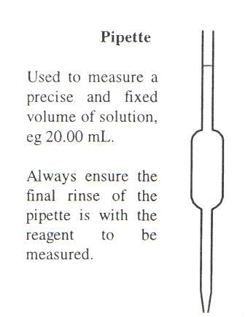
- a few drops of an appropriate indicator is added to the flask.

- the other solution is added from a burette (in a controlled manner) until the reaction is complete and a colour change is observed, signalling the end point of the titration. | 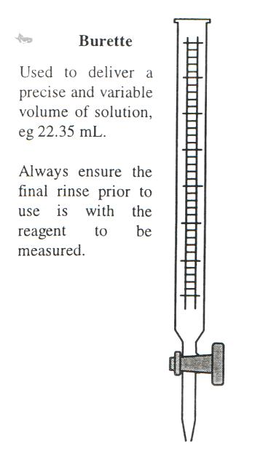

Apparatus used in a titration and cleaning of glassware

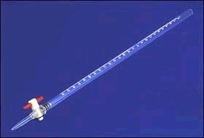
Cleaning glassware
- pipette, burette Burette
  - rinse in detergent
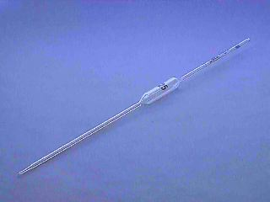
  - rinse in tap water
  - rinse in distilled water
  - rinse with solution to be used

Pipette

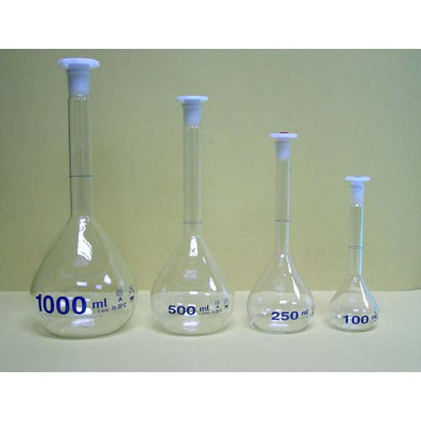
- volumetric flask Volumetric flasks
  - rinse in detergent
  - rinse in distilled water

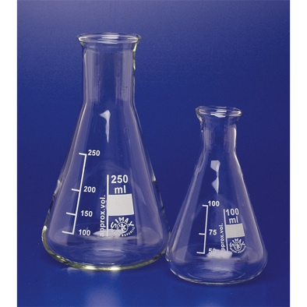
- conical flask Conical flask
  - rinse in tap water
  - rinse in distilled water

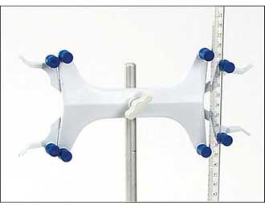
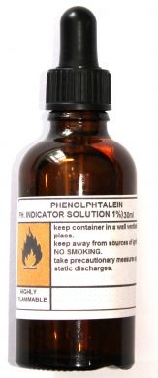
Other apparatus used
- Burette clamp Indicator

Performing the Titration
- Make up a solution of A to 250 mL in a volumetric flask.
- Take out a 20.0 mL sample of A using a pipette.
- Transfer to a conical flask – rest the tip of the pipette on the side of the flask, wait ~15 sec, gently tap the tip once on the side of the flask, a small portion of A remains in the pipette, DO NOT blow this out.

- Add a small quantity of B to the burette. Rinse and discard. Fill burette to above 0 mark with B then run out B to remove air bubble in bottom of burette. (Burette does not need to start at exactly 0)

- Add 2-3 drops of indicator to conical flask (if required).
- Run B into conical flask, swirl flask, stop when colour change occurs. This is a rough trial.

- Repeat titration until consistent volumes (within 0.2 mL) are obtained.
- Perform calculations.
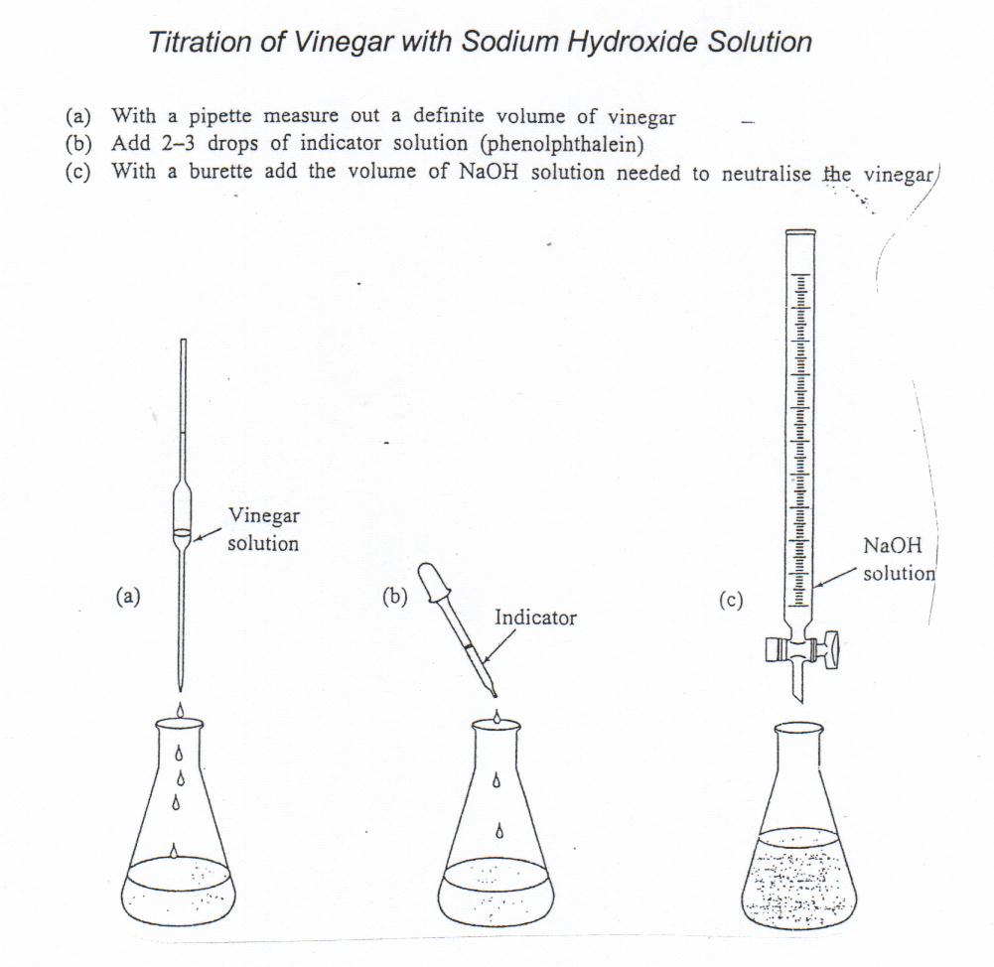
Titration of Vinegar with Sodium Hydroxide Solution

- With a pipette measure out a definite volume of vinegar
- Add 2-3 drops of indicator solution (phenolphthalein)
- With a burette, add the volume of NaOH solution needed to neutralise the vinegar.

- During a titration, 25.0 mL of 0.150 mol L⁻¹ sodium hydroxide was measured into a conical flask, indicator was added, then sulphuric acid of concentration 0.200 mol L⁻¹ was added until neutralisation occurred. What volume of the acid was needed?

- Write a balance equation

- Calculate the number of moles of the known sample – NaOH

- Calculate the number of moles of H⁺

- Calculate the number of moles of H₂SO₄

- Calculate the volume of H₂SO₄

Acid-base indicators are weak acids, or weak bases, in which the acidic form is a different colour from the basic form.

- Acid-base indicators are weak acids, or weak bases, in which the acidic form is a different colour from the basic form

Indicators in Acid-Base Titrations

- An indicator is a substance that changes colour over a specific pH range.

Equivalence Point
- Equivalence point – the point at which chemically equivalent amounts of acid and base are added (when acid and base have been added in sufficient volumes so reaction is complete). Both acid and base are fully consumed.

The ratio of moles of acid and base that have been added is the same as the mole ratio in the balanced equation:

e.g. when HCl neutralises NaOH.
H⁺ + OH⁻ H₂O
1 mole 1 mole 1 mole

The equivalence point occurs when the number of moles of hydrochloric acid equals the same number of moles of sodium hydroxide.

e.g. when HCl neutralises Na₂CO₃
2H⁺ + CO₃²⁻ CO₂ + H₂O
2 mole 1 mole 1 mole 1 mole

The equivalence point occurs when the number of moles of hydrochloric acid equals twice the number of moles of sodium carbonate.

e.g. when H₂SO₄ neutralises NaOH
H₂SO_{4(aq)} + 2OH⁻ SO₄²⁻ + 2H₂O
1 mole 2 mole 1 mole 2 mole

The equivalence point occurs when the number of moles of sodium hydroxide equals twice the number of moles of sulphuric acid.

End Point

- This occurs when the indicator changes colour during a titration – shows reaction is complete (equivalence point).

- pH at the equivalence point can be acidic or basic because of the reaction products that have been formed.

If one of the reaction products is acidic (eg. CO₂, NH₄⁺) then the end point will be acidic.
If one of the products is basic (eg. CH₃COO⁻, PO₄⁻³) the end point will be basic.
- The indicator chosen should change colour at or near the equivalence point pH.
- General Rules:
• Strong acid + strong base – neutral end point
• Strong acid + weak base – acidic end point
• Weak acid + strong base – basic end point
- pH changes very rapidly near the equivalence point of a titration.
- When a strong acid is titrated with a strong base the pH at the equivalence point is 7.
- One drop of NaOH solution can change the pH from 4 to 10.
- At this stage the indicator changes colour i.e. the end point is reached.

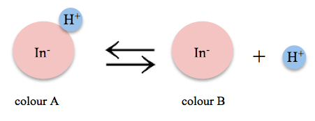
Indicator

- Choice of indicator depends on

- pH of the equivalence point and
- range of colour change of indicator.

  - The indicator must change colour close to the equivalence point and preferably have two distinct colours at different pH.

  - Strong acid – strong base: equivalence point at pH = 7, neutral.

  - Weak acid – strong base: at the equivalence point the pH is on the basic side of 7 (i.e. > 7) due to the formation of OH⁻_{(aq)} by hydrolysis.

  - Strong acid – weak base: at the equivalence point the pH is on the acidic side of 7 (i.e. < 7), again by hydrolysis, but this time H⁺_{(aq)} or H₃O⁺_{(aq)} are formed.

  - Weak acid – weak base: depends but equivalence point should be about 7, neutral
  - general rule
  - s.a. + s.b. = neutral
  - s.a. + w.b. = acidic
  - s.b. + w.a. = basic
  - w.a. + w.b. ~ neutral

  - Ideally, the end point and the equivalence point occur at the same pH. In practice this may not occur as the indicator colour change rarely coincides precisely with the pH at equivalence.
Type of titration | pH at equiv. Point | Indicator | Range of colour change of indicator | Colour
strong acid – strong base  e.g. HCl – NaOH | 7 | bromothymol blue  methyl orange  phenolphthalein  litmus  methyl red | 3.0 – 4.6  3.1 – 4.4  8.3 – 10.0  5.0 – 8.0  4.4 – 6.2 | yellow blue  red orange  colourless pink  red blue  red yellow
strong acid – weak base  e.g. HCl – NH₃ | 5 | methyl orange | 3.1 – 4.4 | red yellow
weak acid – strong base  e.g. CH₃COOH – NaOH | 9 | phenolphthalein | 8.3 – 10.0 | colourless pink
Weak acid – weak base  e.g. CH₃COOH – NH₃ | 7 | Phenolphthalein  Alizarin yellow | 8.3 – 10.0  10.1 – 12.0 | colourless pink  yelloworange

Selection of Indicator
• Acid Base strength strong acid + weak base
HCl + NH₃
Explanation of equivalence pH acidic due to NH₄⁺ - need change in acid region
Suggested indicator and pH methyl orange
for colour change

Colour change when acid is yellow to red
in the flask

• Acid Base strength strong acid + strong base
HCl + NaOH
Explanation of equivalence pH neutral - need change in neutral region
Suggested indicator and pH phenolphthalein
for colour change
pH change at end point
with the addition of one
more drop - 7 to 10

Colour change when acid is colourless to pink
in the flask

• Acid Base strength weak acid + weak base
CH₃COOH + NH₃
Explanation of equivalence pH neutral - need change in neutral region
Suggested indicator and pH phenolphthalein
for colour change (difficult to determine)
Colour change when acid is colourless to pink
in the flask

• Acid Base strength weak acid + strong base
CH₃COOH + NaOH
Explanation of equivalence pH Basic due to CH₃COO⁻ ions - need change in basic
region

Suggested indicator and pH phenolphthalein
for colour change

Colour change when acid is colourless to pink
in the flask

• End point - indicator changes colour. Equivalence point - = stoichiometric ratio

Remember General rules:

• Strong acid + strong base - neutral end point.

• Strong acid + weak base - acidic end point.

• Weak acid + strong base - basic end point.

• Weak acid + weak base ~ neutral end point.

Indicators - pH range
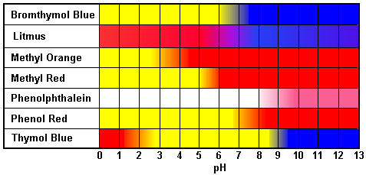
SA + SB

SA + SB

SA + WB

SA + SB

WA + SB

SA + SB

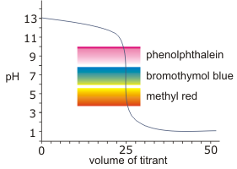
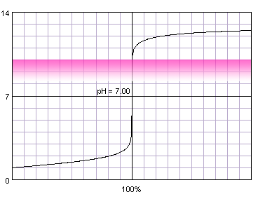
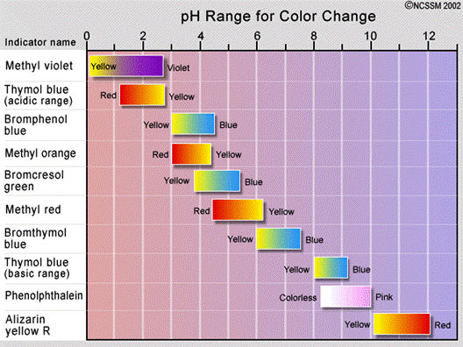

    - Select an indicator for the following titrations and explain your reasons.

Na₂CO₃ and HCl

H₂CO₃ and NaOH

  - Indicators are weak acids in which the anion has a different colour to the acid molecule.
i.e. HIn ⇋ H⁺ + In⁻
colour A colour B

In acid H⁺, colour A is favoured.
In base OH⁻, colour B is favoured.

- methyl orange is
red for pH < 3.1
yellow for pH > 4.4
changes colour on the acid side of neutral.
i.e. used for weak base – strong acid titration.

- phenolphthalein is
colourless for pH < 8.2
pink for pH > 10
changes colour on the basic side of neutral.
i.e. used for strong base – weak acid titration.

  - Note:
  - Indicators are selected so that their end point is as close as possible to the reaction’s equivalence point.
  - In a reaction between a strong acid and a strong base the addition of a very small amount of either solution can have a huge effect on the pH at the end point. i.e. one drop of acid can drop the pH by several units.
  - any indicator that changes colour in the range of 3 – 11 can be used in a strong acid – strong base titration.
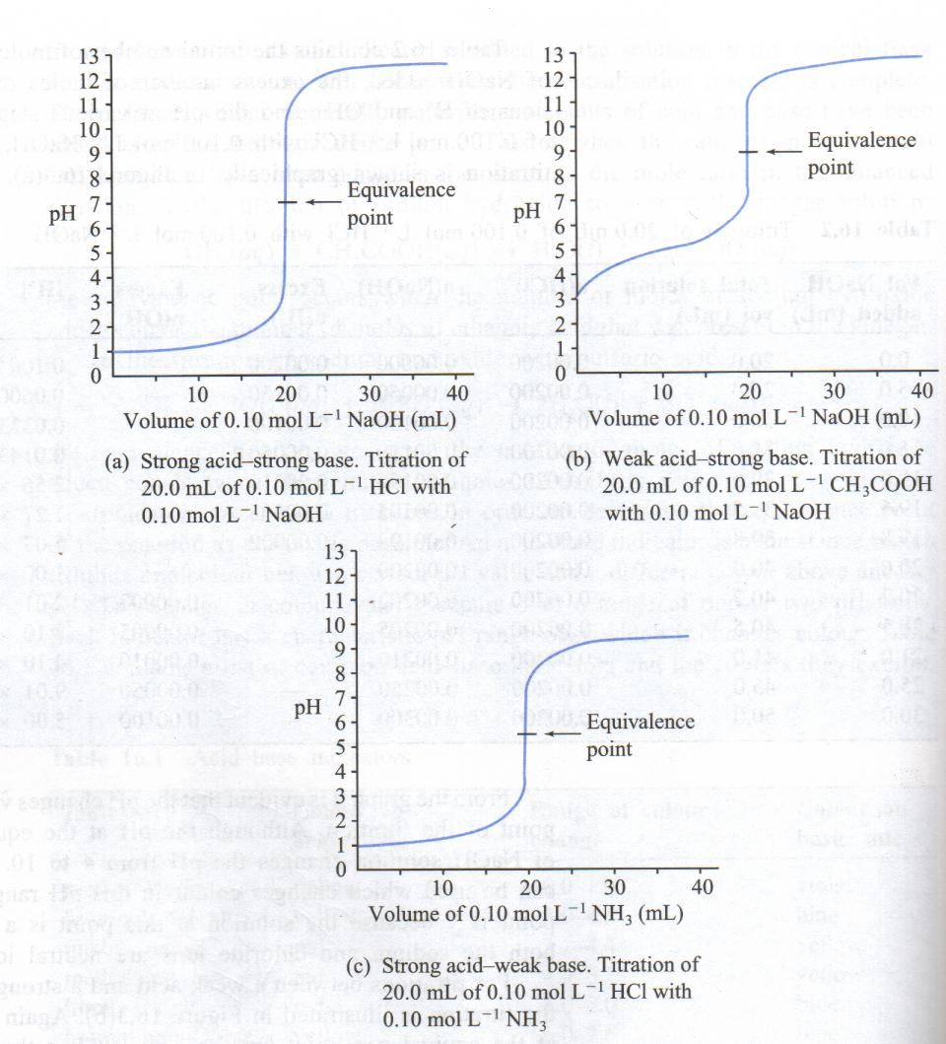
  - Indicators like phenolphthalein are very good because they have very distinct differences in the colours in acid and base and so the end-point can be easily seen.

    - Explain why
- methyl orange is not used in weak acid – strong base titration.

- phenolphthalein is used for weak acid – strong base titrations and for strong acid – strong base titrations.

Titration Curves



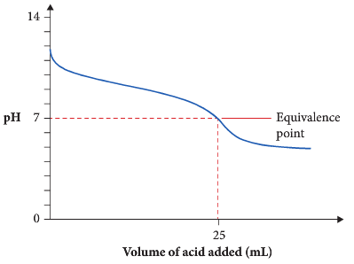
pH graph for a titration involving a weak base and a weak acid.
More examples
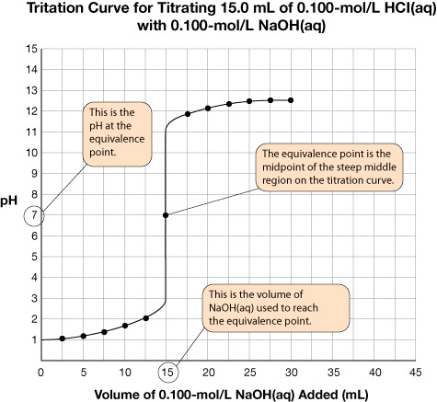

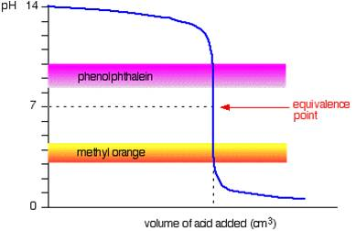

Titration curve of a strong acid and a strong base
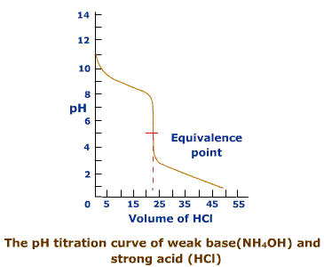
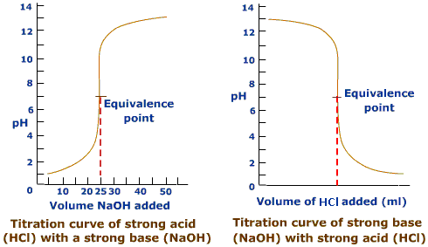

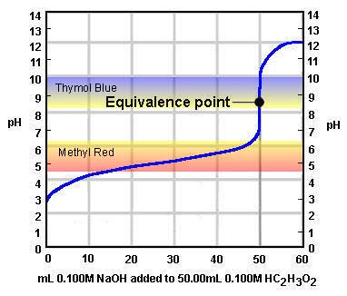
Titration curve of a weak acid (HC₂H₃O₂) and a strong base (NaOH)

    - Problem Set Answers p 36
1. For each of the following titrations identify:
(i) The substance present at the equivalence point (write the equation first).
(ii) Whether the solution at the equivalence point is acidic, basic or neutral.
(iii) An appropriate indicator for the titration.

a. The titration of hydrofluoric acid with sodium hydroxide solution.
Equation:
Substance present:
Acidic or basic: Indicator:

b. The titration of potassium hydroxide with nitric acid.
Equation:
Substance present:
Acidic or basic: Indicator:
c. The titration of sodium carbonate with hydrochloric acid.
Equation:
Substance present:
Acidic or basic: Indicator:

2. In the titration of ethanoic acid with sodium hydroxide solution, phenolphthalein is an appropriate indicator. If methyl orange was used as the indicator, what effect would this have on the apparent volume of sodium hydroxide required for neutralisation?

3. Explain why the following substances are not suitable for use as a primary standard?
- sodium hydroxide

- hydrochloric acid

4. A student carrying out a titration between HCl acid and ammonia used phenolphthalein as an indicator.
- Is this an appropriate indicator?
- Explain clearly why/why not.

5. A student is performing a titration and has a 25.0 mL solution that is at pH of 9.0 due to a higher [OH⁻] than [H⁺]. Calculate the [H⁺].

Calculate the number of moles of OH⁻.

1 drop of 1 M HCl is added. Assuming the volume of 1 drop is 0.05 mL, calculate the new pH.

Data obtained from acid-base titrations can be used to calculate the masses of substances and concentrations and volumes of solutions involved.

Acid-Base Calculations in volumetric analysis

- Finding the Concentration of a Primary Standard Solution

A sodium carbonate primary standard solution is prepared by dissolving 3.747 g of Na₂CO₃ solid in approximately 100 mL of water and then making up to the mark in a 500 mL volumetric flask. Determine the concentration of this solution.

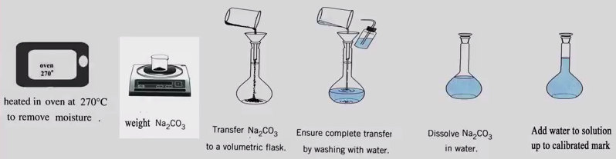

Find the moles of Na₂CO₃ used. | n(Na₂CO₃) = m = 3.747 = 0.03535 mol  M [(22.99 x 2) + 12.01 + (16 x 3)]
Find conc. of Na₂CO₃ | c(Na₂CO₃) = n = 0.03535 = 7.07 x 10⁻² mol L⁻¹  V 0.500

- Find the Concentration of a Solution from Titration Data

Determine the concentration of ethanoic acid in a diluted vinegar solution if 20.00 mL portions of vinegar are titrated with 7.070 x 10⁻² mol L⁻¹ sodium carbonate solution. Several titrations were performed and the volumes of sodium carbonate solution were 23.55 mL, 22.85 mL, 22.70 mL and 22.80 mL.

Find av. titration vol. Discard 23.55 | V(average) = 22.85 + 22.70 + 22.80 = 22.78 mL  3
Find the av. moles of Na₂CO₃ | n(Na₂CO₃) = cV = 7.070 x 10⁻² x 22.78 x 10⁻³ = 1.611 x 10⁻³ mol
2 moles react with 1 mole | 2CH₃COOH + Na₂CO₃ 2 NaCH₃COO + H₂O + CO₂
Calculate moles of CH₃COOH | n(CH₃COOH) = 2 x n(Na₂CO₃) = 2 x 1.611 x 10⁻³  = 3.222 x 10⁻³ mol
Calculate conc. of CH₃COOH | c(CH₃COOH) = n = 3.22 x 10⁻³ = 1.61 x 10⁻¹ mol L⁻¹  V 20 x 10⁻³

    - Questions

- Write equations for the following reactions and calculate the volume of 0.500 mol L⁻¹ sodium hydroxide required to neutralise

  - 100 mL of 2.00 mol L⁻¹ hydrochloric acid.

HCl + NaOH NaCl + H₂O Ionic: H⁺ + OH⁻ H₂O

n(HCl) = c V

=
=

1 mol H⁺ reacts with 1 mol OH⁻

n(NaOH) =

V(NaOH) = n/c
=

=
  - 20.0 ml of 0.250 mol L⁻¹ sulphuric acid.

- In a titration, 0.105 mol L⁻¹ HCl is used to standardise KOH solution using phenolphthalein as an indicator. 21.1 mL of the acid is needed to neutralise 25.0 mL of KOH solution. What is the concentration of the KOH solution?

H⁺ + OH⁻ H₂O

n(HCl) = c V =
=
1 mol H⁺ reacts with 1 mol OH⁻

n(KOH) =

c(KOH) = n/V = =

- The concentration of an unknown sodium carbonate solution was to be determined by titration with 1.00 M nitric acid using methyl orange indicator. 3.5 mL of nitric acid was added to 25.0 mL of sodium carbonate when a colour change from yellow to red indicated the end-point of the titration. What is the concentration of the sodium carbonate solution?

2H⁺ + CO₃²⁻ CO₂ + H₂O

n(HNO₃) = c V =
=
2 mol H⁺ reacts with 1 mol CO₃²⁻

n(Na₂CO₃) =

c(Na₂CO₃) = n/V
=

=

- 24.4 mL of HCl is needed to neutralise 25.0 mL of 0.104 M NaOH solution.
Calculate
  - the concentration of HCl in mol L⁻¹ and g L⁻¹
  - the volume of the original acid solution needed to make 1.00 mL of 0.100 M solution and
  - the volume of water which must be added to 2.00 L of the original acid solution to make it 0.100 mol L⁻¹.

(a) n(NaOH) = c V =
=
1 mol H⁺ reacts with 1 mol OH⁻

n(HCl) =
n = m/M
c(HCl) = n/V
g L⁻¹ = mol L⁻¹ x M
= m = n M
=
mol L⁻¹ = M
g L⁻¹
= = g in L
= gL⁻¹

(b) c₁V₁ = c₂V₂
V₁ = =

=
(c) c₁V₁ = c₂V₂
V₂ = =

= i.e. add mL
- A sample of vinegar has a density of 1.01 g mL⁻¹ and contains 3.00 % by mass of ethanoic (acetic) acid. What volume of 0.500 M potassium hydroxide is required to neutralise 25.0 mL of the vinegar?

3.00 % of 1.01 g = g mL⁻¹ ethanoic acid CH₃COOH

n (CH₃COOH) = m/M
=

= =

1 mol H⁺ reacts with 1 mol OH⁻

n(KOH) =

V(KOH) = n/c
=
=
=

- Titration Calculation Involving a Dilution

Prior to analysis, a vinegar solution is diluted by pipetting 50.00 mL of it into a 250 mL volumetric flask and making this up to the mark with distilled water.
A 20.00 mL sample of diluted vinegar required on average 23.65 mL of 7.070 x 10⁻² mol L⁻¹ sodium carbonate solution to reach the end point. Determine the concentration of ethanoic acid in the undiluted vinegar solution.

Find the av. moles of Na₂CO₃ | n(Na₂CO₃) = cV = 7.070 x 10⁻² x 23.65 x 10⁻³ = 1.672 x 10⁻³ mol
2 moles react with 1 mole | 2CH₃COOH + Na₂CO₃ 2 NaCH₃COO + H₂O + CO₂
Calculate moles of CH₃COOH | n(CH₃COOH) = 2 x n(Na₂CO₃) = 2 x 1.672 x 10⁻³  = 3.344 x 10⁻³ mol
Calculate conc. of CH₃COOH | c(CH₃COOH) = n = 3. 344 x 10⁻³ = 1.672 x 10⁻¹ mol L⁻¹  diluted V 20 x 10⁻³
Find original conc. of CH₃COOH | c_{o} x v_{o} = c_{n} x v_{n} c_{o} = c_{n} x v_{n}  v_{o}
c_{o} = 1.672 x 10⁻¹ x 250 x 10⁻³ = 0.836 mol L⁻¹
50 x 10⁻³
- Another method without calculating the concentration of CH₃COOH in diluted solution:

2CH₃COOH + Na₂CO₃ → 2NaCH₃COO + H₂O + CO₂
2 mol 1 mol

thus n(CH₃COOH in 20.00 mL aliquot) = 2 x n(Na₂CO₃) = 3.344 x 10⁻³ mol.
n(CH₃COOH in 250 mL of diluted solution) =
= 0.0418 mol

n(CH₃COOH in original 50.00 mL) = n(CH₃COOH in 250 mL of dilute solution

= 0.0418 mol

c(CH₃COOH in original 50.00 mL) =

= 0.836 mol L⁻¹

    - Questions

- An analyst has a pure substance ‘A’ which is a weak acid and she decides
to determine its molecular weight by titration.
She dissolves 1.3867 g of ‘A’ in water and makes the solution up to 250.0 mL
in a volumetric flask. She then titrates 20.00 mL portions of the solution ‘A’
with 0.09826 mol L⁻¹ sodium hydroxide from the burette using phenolphthalein
as indicator, and records the following titration figures.

Initial reading (mL) | 20 | 19.5 | 18.32 | 17.77 | 18.87
Final reading (mL) | 0.11 | 1.32 | 0.67 | 0.08 | 1.20

- Calculate the appropriate value for the volume of sodium hydroxide required for titration.
- Assume that ‘A’ is monoprotic acid and calculate the number of moles of ‘A’ in the 1.3867 g of ‘A’.
- Use this value to calculate the molecular weight of ‘A’.
- Assume that ‘A’ is a diprotic acid and calculate its molecular weight.
- Assume that ‘A’ is a triprotic acid and calculate its molecular weight.

- 17.67 mL (reject first 2 trials)
- 0.0217 mol
- 63.8
- 127.6
- 191.4

    - Problem Set
1. Prior to analysis, an HCl _{(aq)} solution is diluted by transferring 15.00 mL of it into a 250.0 mL volumetric flask and making it up to this mark with distilled water. A 20.00 mL sample of diluted HCl _{(aq)} required on average 16.65 mL of 9.080 x 10⁻² mol L⁻¹ NaOH _{(aq)} for equivalence. Determine the concentration of HCl _{(aq)} in the undiluted solution.

Diagrams are often helpful

2. A student prepared a primary standard of Na₂CO₃ by dissolving 1.320 g of pure anhydrous sodium carbonate and making it up to 250.0 mL in a volumetric flask. This solution was used to standardise some HCl acid. A 20.00 mL aliquot of the Na₂CO₃ solution required on average 21.20 mL of the acid for a complete reaction. Calculate:
a. the concentration of the Na₂CO₃ solution.
b. the concentration of the HCl solution.

3. A 1.252 g sample of an oven cleaner containing mostly sodium hydroxide was dissolved and made up to 250.0 mL using a volumetric flask. A 20.00 mL aliquot of this solution was titrated against 0.09500 mol L⁻¹ HCl and required 23.85 mL of this acid to reach end point. Calculate the percentage (by mass) of NaOH in the oven cleaner.

4. A 15.50 g sample of commercial vinegar was diluted and made up to 250.0 mL in a volumetric flask. A 20.00 mL aliquot of this diluted vinegar required 17.75 mL of
0.05050 mol L⁻¹ NaOH solution to complete neutralisation.
a. What indicator would be suitable for this titration?
b. Determine the % by mass of ethanoic acid in the commercial vinegar solution.
c. Determine also the concentration of the ethanoic acid in commercial vinegar (in
mol L⁻¹ and g L⁻¹). Assume the density of vinegar is 1.000 g mL⁻¹.

5. A procedure to determine the hydrochloric acid concentration in an approximately 9 mol L⁻¹ solution of HCl _{(aq)} involved the following steps:

Preparation of a primary standard.
A carefully weighed 1.288 g sample of anhydrous Na₂CO₃ _{(s)} was dissolved in water and made up to 250.0 mL.
Dilution of the original approximately 9 mol L⁻¹ HCl solution.
A 25.00 mL sample of the acid was added to a 2.000 L volumetric flask and made up to the mark.
Titration of the diluted acid.
20.00 mL samples of the diluted acid solution required on average 20.62 mL of primary standard for equivalence.

a. Write an equation for the titration reaction.
b. Suggest a suitable indicator for the equivalence point for this titration.
c. Determine the concentration of the diluted acid.
d. What is the concentration of the original approximately 9 mol L⁻¹ acid?

6. A batch of battery acid was analysed to find its sulfuric acid content. To do this 50.00 mL of the acid was taken and diluted to 250.0 mL in a volumetric flask. 25.00 mL samples of the diluted acid were titrated with 1.029 mol L⁻¹ KOH _{(aq)} solution. The initial and final burette readings are shown:

Final Volume (mL) | 41.00 | 39.65 | 41.90 | 41.30
Initial Volume (mL) | 1.05 | 0.40 | 2.60 | 1.95
Volume used (mL)

a. How can the equivalence point of this titration be determined?
b. What was the concentration of the H₂SO₄ _{(aq)} in the original battery acid?
c. What was the concentration of H₂SO₄ _{(aq)} in ppm if the original acid solution have a density of 1.21 g mL⁻¹?

Back Titrations

  - A back titration, or indirect titration, is generally a two-stage analytical technique.

  - Reactant A of unknown concentration is reacted with excess reactant B of known concentration.

  - A titration is then performed to determine the amount of reactant B in excess. From calculations, the amount of reactant B used can be determined and then the concentration of reactant A can be determined.

  - Back titrations are used in a number of situations. For example:
- one of the reactants is volatile, for example ammonia.
- an acid or a base is an insoluble solid, for example calcium carbonate
- a particular reaction is too slow
- direct titration would involve a weak acid - weak base titration
- the end-point of this type of direct titration is very difficult to observe

A 2.50 g sample of limestone was dissolved in 75.0 mL of 0.996 mol L⁻¹ hydrochloric acid. After heating to remove all the CO₂, the solution was cooled and diluted to 250 mL. A 25.0 mL sample of the diluted solution was titrated with 25.27 mL of a standardised of 0.1215 mol L⁻¹ sodium hydroxide. Determine the percentage of calcium carbonate in the original limestone sample.

NaOH + HCl NaCl + H₂O

n(NaOH) = cV = 0.1215 x 0.02527 = 0.003070 mol

n(HCl 25 mL sample) = 0.003070 mol

n(HCl 250 mL) = 10 x 0.003070 = 0.03070 mol

n(HCl original) = cV = 0.996 x 0.0750 = 0.0747 mol

n(HCl reacted) = 0.0747 – 0.03070 = 0.0440 mol

2HCl + CaCO₃ CaCl₂ + CO₂ + H₂O

n(CaCO₃) = ½ n(HCl) = 0.0220 mol

m(CaCO₃) = n x M
= 0.0220 x 100.09 = 2.201 g

%( CaCO₃) = 2.201/2.50 x 100 = 88.1%

7. Vitamin C contains the active ingredient ascorbic acid (C₆H₈O₆). This is weak acid that releases one mole of hydrogen ions per mole of acid molecules. A single vitamin C tablet of mass 3.550 g is crushed and dissolved in 500.0 mL of 4.640 x 10⁻¹ mol L⁻¹ NaOH. A 20.00 mL sample of the solution containing the excess NaOH was then titrated to equivalence with 38.48 mL of 0.1120 mol L⁻¹ H₂SO₄ _{(aq)}. What mass of vitamin C is present in the 3.550 g tablet?



8. A 2.972 g sample of an unknown metallic element was dissolved in 125.0 mL of 2.107 mol L⁻¹ HNO₃ _{(aq)} and made up to 250 mL in a volumetric flask. The reaction produced a salt with formula M(NO₃)₄.
3M _{(s)} + 16HNO₃ _{(aq)} → 3M(NO₃)₄ _{(aq)} + 4NO _{(g)} + 8H₂O _{(l)}

20.00 mL sample of the diluted solution containing excess HNO₃ _{(aq)} was titrated to equivalence using 32.95 mL of 0.3152 mol L⁻¹ NaOH _{(aq)}. What is the molar mass of the metal? Use your answer to identify the metal element.

EXTRA INFORMATION (Revision)

1. Important Acids

Hydrochloric, sulphuric and nitric acids are three acids commonly encountered in the laboratory and used extensively in industry.

Hydrochloric acid

- Physical properties include
- colourless
- strong, pungent odour due to release of HCl gas
- poisonous and toxic to life
- made by dissolving hydrogen chloride in water to produce a solution which
  - is 36-38% by mass HCl, about 12 M solution
  - has a density of 1.19.g mL⁻¹
  - conducts electricity
  - completely ionised in water
- hydrogen chloride is a molecular gas which readily ionises in water forming H⁺_{(aq)} and Cl⁻_{(aq)}.
- strong acid

- Chemical properties include
- highly reactive with
  - metals to produce H₂ gas
2H⁺ + Ca H₂ + Ca²⁺
  - bases to produce salt and water
Pb(OH)₂ + H⁺ + Cl⁻ 2H₂O + PbCl₂
CuO + 2H⁺ Cu²⁺ + H₂O
  - carbonates and hydrogen carbonates to produce CO₂, salt and water
CO₃²⁻ + 2H⁺ H₂CO₃ ⇋ H₂O + CO₂
- corrosive
- react with ammonia – this is a test for HCl gas. White fumes of NH₄Cl are produced when the two gases mix.

- Commercially manufactured by two main processes
- burning chlorine in hydrogen
H_{2(g)} + Cl₍₂₎ 2HCl_{(g)}
- reaction between salt and sulphuric acid
2NaCl_{(s)} + H₂SO_{4(aq)} 2HCl_{(g)} + 2Na₂SO_{4(aq)}

- Industrial uses include
- cleaning brickwork (dissolves mortar)
- cleaning iron sheeting prior to galvanising
- solvent (with nitric acid) for gold and platinum
- as a laboratory reagent in the manufacture of plastics and other organic compounds
- used in plastics industry
- used to from hydrochloric acid solutions HCl_{(aq)}

Sulphuric Acid

- Physical properties include
- colourless
- ionises in two stages
H₂SO_{4(aq)} + H₂O_{(l)} H₃O⁺_{(aq)} + HSO₄⁻_{(aq)}
HSO₄-_{(aq)} + H₂O_{(l)} ⇋ H₃O⁺_{(aq)} + SO₄²⁻_{(aq)}
- dense liquid, ρ = 1.84 g mL⁻¹
- high BP (338⁰C) makes H₂SO₄ suitable in the production of other acids such as HCl which is driven off at a lower temperature.

- Chemical properties include
- highly toxic and corrosive
- strong oxidiser when concentrated
For example,
Cu_{(s)} + 2H₂SO_{4(aq)} ⇋ CuSO_{4(aq)} + 2H₂O_{(l)} + SO_{2(g)}
- strong affinity for water
  - heat released (exothermic)
  - acts as a dehydrating agent

- Manufactured by
- contact process
- lead chamber process
  - sulphur dioxide is oxidised to sulphur trioxide by reacting nitric oxide with oxygen. The two steps are
2NO_{(g)} + O_{2(g)} ⇋ 2NO_{2(g)}
SO_{2(g)} + NO_{2(g)} ⇋ SO_{3(g)} + NO_{(g)}
  - the NO acts as a catalyst and is recovered and re-used
  - the concentration of the final H₂SO₄ solution is low (70%) compared to that of the contact process (98%)

- Industrial uses include
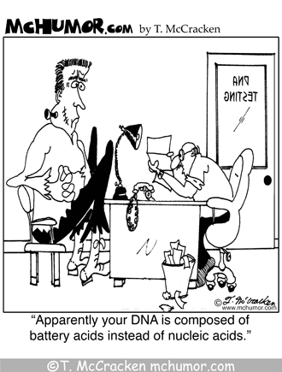
- manufacture of
  - other acids such as HCl and HNO₃
  - superphosphate fertiliser from rock phosphate
  - detergents
  - titanium oxide from mineral beach sands (ilmenite)
  - explosives
- cleaning surfaces before galvanising
- electrolyte in lead storage batteries which is 35% H₂SO₄

Possible Essay Topics

  - A batch of solid sodium chloride has become contaminated with sodium hydroxide. Rough analytical tests show that the impure sodium chloride contains between 3% and 5% sodium hydroxide by weight.
You are provided with pure anhydrous sodium carbonate and concentrated hydrochloric acid. You also have available to you the apparatus normally available in a high school laboratory together with any indicators that you require. Describe how you would determine the percentage purity of the sodium chloride.
Besides experimental procedure, your answer should contain information about the quantities of materials that you would use, and details of the steps you would take to obtain an accurate answer.

  - Explain and distinguish between the Arrhenius and Lowry-Brønsted models of acid-base behaviour of
- water
- hydrogen chloride
- sodium hydroxide
- a salt that is neutral in water
- a salt that is acidic in water
- a salt that is basic in water
Be careful with your use of the symbols and ⇋.

Review

1. a) Why do aqueous solutions all conduct electricity?
  - Explain why an aqueous solution of an acid conducts electricity better than a more dilute solution of the same acid.
- Explain why an aqueous solution of a strong acid conducts electricity better than an aqueous solution of a weak acid when the concentration of both solutions is the same.

- What are the main species present in the following solutions?
- 0.0010 mol L⁻¹ nitric acid solution
- 0.010 mol L⁻¹ acetic acid solution
- 0.0010 mol L⁻¹ sodium hydroxide solution
d) 0.100 mol L⁻¹ ammonia solution

- Describe what happens in each of the following cases. Write an equation where appropriate.
- A piece of aluminium is placed in a dilute solution of caustic soda.
- A piece of aluminium is placed in a dilute solution of hydrochloric acid.

- Write an equation to explain why aluminium sulphate is used by gardeners to increase the acidity of the soil.

- Explain why the carbonate ion is a fairly strong base, but the sulphate ion is an extremely weak base and the chlorine ion is not a base.

- Aqueous solutions of sodium sulphide, sodium phosphate and sodium carbonate are all basic.
  - Explain why these are basic.
  - Write equations to represent the reactions that cause their aqueous solutions to be basic.

- Essay: Describe how you might determine the molarity of an approximately 0.1 mol L⁻¹ hydrochloric acid solution using sodium carbonate. Your answer should include all relevant equipment and steps involved in the procedure. You should indicate the quantities of substances needed.

    - Problem Set p 14
1.
a. The titration of hydrofluoric acid with sodium hydroxide solution.
Equation: HF _{(aq)} + NaOH _{(aq)} → Na⁺_{(aq)} + F⁻_{(aq)} + H₂O _{(l)}
Substance present: Na⁺_{(aq)} ; F⁻_{(aq)} ; H₂O _{(l)}
Acidic or basic: basic due to F⁻_{(aq)} Indicator: phenolphthalein

b. The titration of potassium hydroxide with nitric acid.
Equation: KOH _{(aq)} + HNO_{3 (aq)} → K⁺_{(aq)} + NO₃⁻_{(aq)} + H₂O _{(l)}
Substance present: K⁺ ; NO₃⁻ ; H₂O
Acidic or basic: Neutral Indicator: phenolphthalein, methyl red, litmus
c. The titration of sodium carbonate with hydrochloric acid.
Equation: Na₂CO_{3 (s)} + HCl _{(aq)} → Na⁺_{(aq)} + Cl⁻_{(aq)} + CO_{2 (g)} + H₂O _{(l)}
Substance present: Na⁺_{(aq)} ; Cl⁻_{(aq)} ; CO_{2 (g)} ; H₂O _{(l)}
Acidic or basic: acidic due to CO₂ Indicator: methyl orange

2. In the titration of ethanoic acid with sodium hydroxide solution, phenolphthalein is an appropriate indicator. If methyl orange was used as the indicator, what effect would this have on the apparent volume of sodium hydroxide required for neutralisation?

The solution at equivalent point would contain sodium ethanoate – an alkaline solution. Methyl orange is suitable for acidic solutions, so if methyl orange was used it would change colour (end point) before the equivalence point was reached. Therefore the volume added would be less than required to reach equivalence point.

3. Explain why the following substances are not suitable for use as a primary standard?
- sodium hydroxide
difficult to obtain pure
deliquescent (absorbs water)
- hydrochloric acid
not pure, results from dissolving an approximate amount of gas in solution.

4. A student carrying out a titration between HCl acid and ammonia used phenolphthalein as an indicator.
- Is this an appropriate indicator? No
- Explain clearly why/why not.
Neutralisation produces an acidic end point due to presence of ammonium ion. Phenolphthalein only suitable for basic and neutral equivalence points.

5. A student is performing a titration and has a 25.0 mL solution that is at pH of 9.0 due to a higher [OH⁻] than [H⁺]. Calculate the [H⁺].

[H⁺] = 10^{-pH} = 10⁻⁹ = 1 x 10⁻⁹ mol L⁻¹

Calculate the number of moles of OH⁻.

[OH⁻] = (1 x 10⁻¹⁴)/( 1 x 10⁻⁹) = 1 x 10⁻⁵ mol L⁻¹ pOH = 5 [OH⁻] = 1 x 10⁻⁵ M
n(OH⁻) = cV = 1 x 10⁻⁵ x 0.025 = 2.5 x 10⁻⁷ mol n(OH⁻) = 2.5 x 10⁻⁷ mol

1 drop of 1 M HCl is added. Assuming the volume of 1 drop is 0.05 mL, calculate the new pH.

n(H⁺) = cV = 1 x 0.00005 = 0.00005 = 5.0 x 10⁻⁵ mol
excess H⁺ = n(H⁺) - n(OH⁻) = 5.0 x 10⁻⁵ – 2.5 x 10⁻⁷ = 4.975 x 10⁻⁵ mol c=n/V = 1.99x10⁻³
pH = -log₁₀ [H⁺] = - log₁₀(1.99 x 10⁻³) = 2.7

